Project Report
1. Cover Page
- Project Name: US Staffing Project
- Name: Khushboo Sharma
- Role: Business Data Analyst
- Tools Used: Python, SQL, Power BI

2. Project Overview
This project focuses on a US IT staffing company that works exclusively with prime vendors. The primary objective is to analyze the performance of Business Development Managers (BDMs) and recruiters from January to June. The project also provides insights into revenue generation, gross margin, and hiring trends during this period using Python for data cleaning, SQL for data analysis, and Power BI for interactive dashboard visualization.

3. Business Objective
- Analyse the Recruiters and BDMs individual performances.
- Tracking the revenue.
- Tracking each BDM and Recruiters billing.
- Analyse which job role are in more demand
- Identifying Clients

4. Dataset Description
Column | Description
Candidate ID | Unique candidate identifier
Recruiters | Recruiters working in company
BDM | Business Development Manager
Bill Rate | Client billing rate
Margin | Gross margin
Candidate Status | Current stage of candidate

5. Data Cleaning (Python)
After loaded the excel file, checked if the dataset is properly loaded in Python for cleaning.
For cleaning the dataset, I have done the following –
- Checked for duplicate values by using – isnull().sum()
- Filled the null values with default values by using fillna()
- Checked datatypes of each column by using df.datatype and converted the date columns
- Corrected the column names by removing space and moved into all lower case.
- Validate the bill rate and pay rate and changed their datatypes into float.

6. SQL Analysis
- Total Placements
- Revenue
- Gross margin
- Best client
- Best recruiter
- Top BDM
- Job Category Analysis

7. Dashboard KPIs
In SQL analysis, firstly I have used some simple DAX queries for KPIs –
- Revenue
- Gross Margin
- Total placements
- Total BDMs
- Total Recruitments

8. Dashboard Visuals
- Used Slicers to show BDMS and Recruiters.
- Showed which job category has the highest number of placements by using stacked column chart.
- Used pie chart to show the job types placements.
- Showed how submissions are taking place over time by line chart.
- Showed candidate status by donut chart.
- See the screenshot of Dashboard.

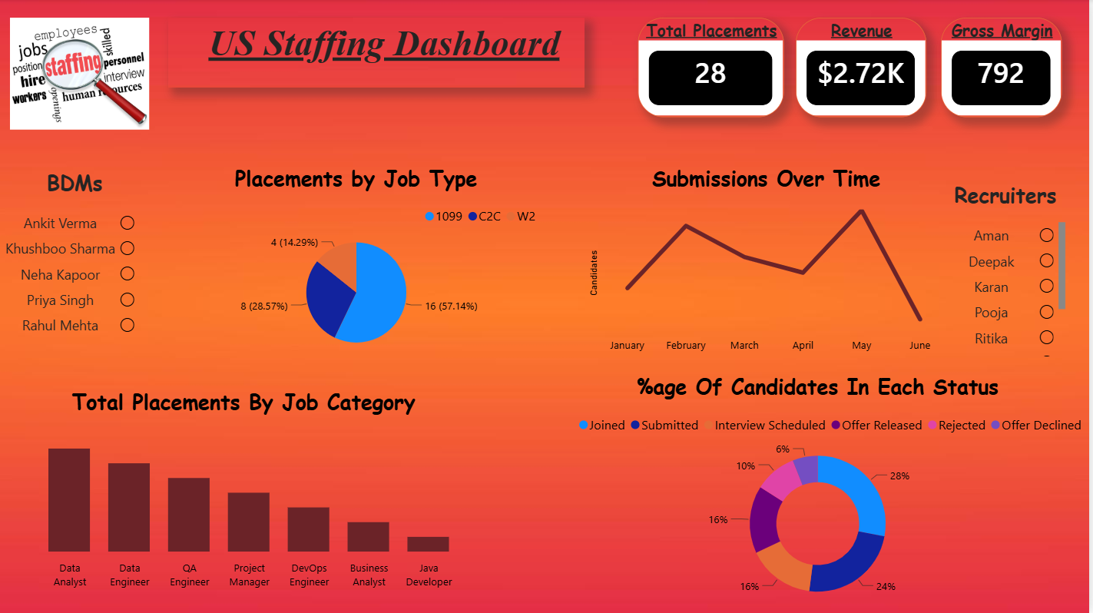

9. Key Insights
- Maximum candidates are submitted in May Month.
- BDM Khushboo Sharma achieved most placements.
- Vikas doesn’t have any placement.
- Recruiter Pooja achieved the most placements.
- Data Analyst had the highest number of placements.
- Gross margin increased with successful joining.

10. Recommendations
- Focus on high-revenue clients.
- Improve conversion from Interview to Joined.
- Support recruiters with lower placement rates.
- Increase hiring in high-demand job categories.

11. Tools Used
- Python
- Pandas
- MySQL
- Power BI
- DAX

12. Conclusion
This project demonstrates an end-to-end data analytics workflow, from data cleaning and SQL analysis to interactive dashboard creation. The dashboard provides actionable insights into staffing performance and supports better business decision-making.

